Nov. 16, 2022 VMICC Equity Committee Notes

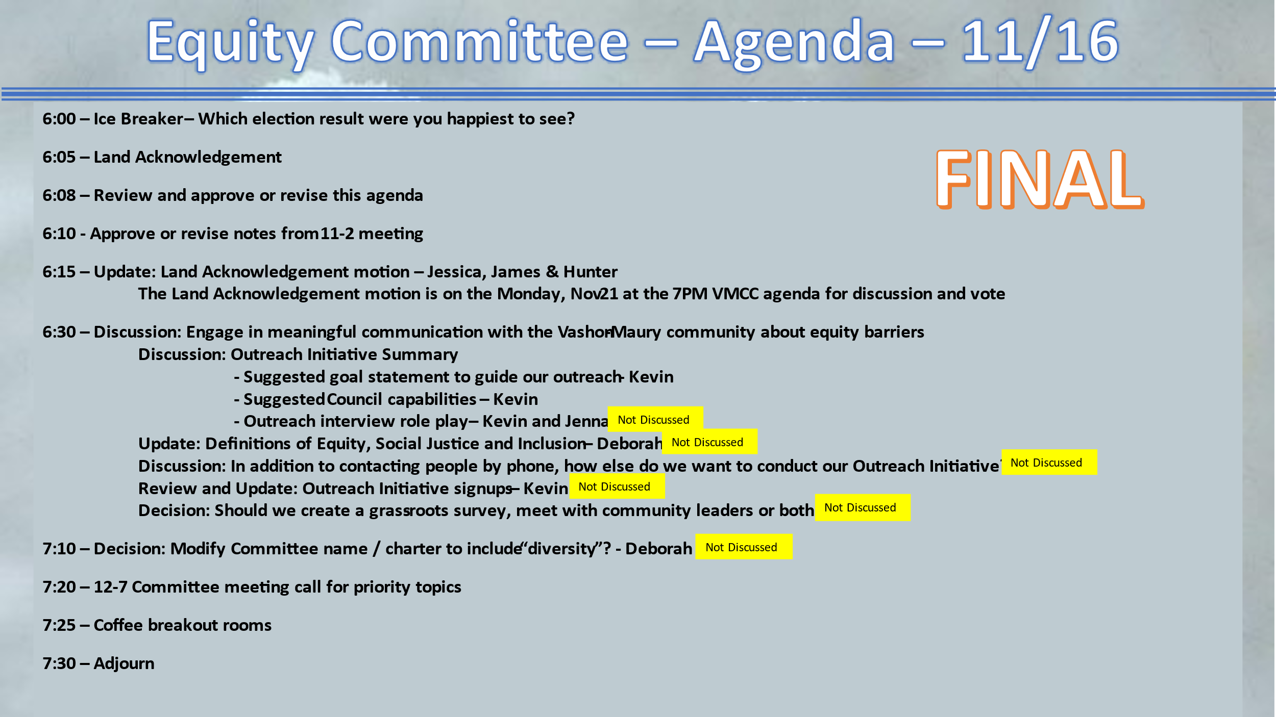

Present: Kevin Jones, James Rickard, Jenna Riggs, Jessica Anakar, Kathleen Fitch, Terry Sullivan, Allison Trundle, Deborah Anderson, Yvonne Kuperberg, Jess Lisovsky

The meeting convened at 6 pm.

The land acknowledgement was read by Kevin.

Approve/revise notes from 11/2: Approved and ready to be published on the VMICC website.

Update: Land Acknowledgement motion latest status
Jessica & James
The first zoom meeting happened — Jessica reports that the meeting went well and they got a lot of great feedback. They are also seeing that there is interest and enthusiasm to make sure that actions are included, and make sure that it is not just performative.

The next zoom meeting is Nov. 29th.

Nov. 21 is the meeting at the Community Council to vote on the motion to include a land acknowledgment at the beginning of each council meeting.

Discussion: Engage in meaningful communication with the Vashon-Maury community about equity barriers

• Outreach Initiative Summary
See “2022-11-2 VMCC EC Slide Notes.pptx”
– Reviewing and fine tuning the Outreach Initiative – Goal Statement
This statement is mainly for the group to use for now, as a guide.

- Council Capabilities
What can the council actually do to improve islanders’ lives?
See meeting slide notes

- Coffee pairings
Allison and Deborah
Yvonne and Kevin
Terry and James

Next meeting December 7, 6:00 pm

